CORPORATE PARTNERSHIP

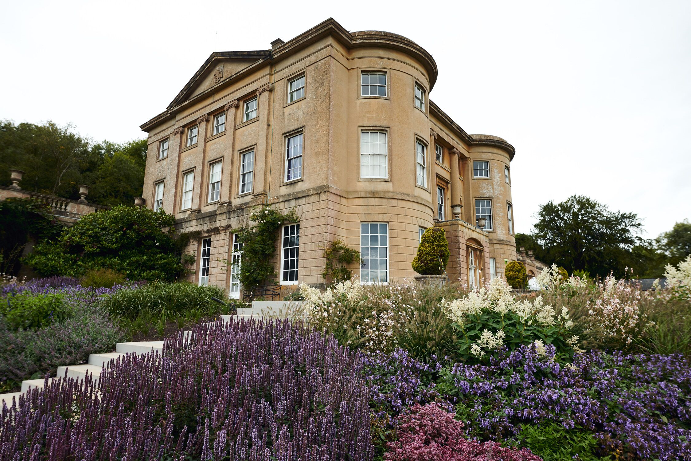

Benefits of Corporate Partnership

Six family membership cards (2 adults and up to 5 children) for your colleagues to use
Free entrance to the Museum, grounds and exhibitions with membership card
40% discount on room hire – perfect for off-site meetings
Six double invitations to our Private Views and Special Exhibition openings
Two invitations to dinner at the Museum Director’s special events
Volunteering opportunities to support your Corporate Social Responsibility goals
Recognition of your support with be included in our Museum publications and on our website

Annual Membership £1,500 + VAT
Profile of The American Museum & Gardens

The mission of the American Museum is to educate, stimulate and inspire its visitors, in order to further the understanding of American history and culture. The Museum carries out this mission through historic rooms, decorative art, folk art collections, special exhibitions, publications, learning programs and gardens. Our organisation is the only one of its kind outside the boundaries of the United States.

Claverton Manor is a Grade 1-listed manor house located at the top of a parkland overlooking the Limpley Stoke Valley on the outskirts of Bath. The estate of 125 acres is a historic registered park, garden and surrounding wood, situated in a Cotswold area of outstanding natural beauty.

The American Museum was founded in 1961 with a collection of over 12,000 objects including Shaker furniture, quilts, textiles and Renaissance maps of the New World. There is also a gallery devoted to the museum's world-class collection of American folk art. The American Heritage Exhibition tells the stories of the Founding Fathers, Native Americans, African Americans, and the Civil War. | 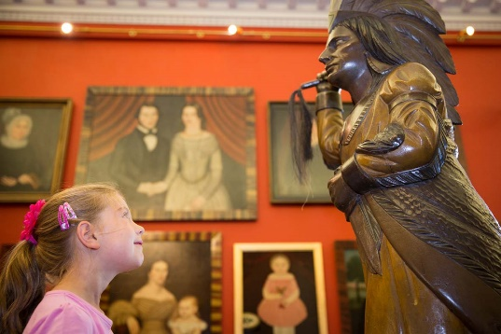
Additional buildings on the estate offer space for annual temporary exhibitions, seminars, lectures, concerts, small exhibitions, weddings and dinners. We have a Museum shop and café. We host formal and informal lectures, workshops, community engagement and family-friendly events.

The New American Gardens

The fully accessible gardens include a replica of George Washington’s Upper Garden at Mount Vernon and a New American Garden, created by the award-winning landscape architectural firm Oehme van Sweden in Washington. The gardens encourage wildlife and birds of prey to a rich landscape, which is home to many ancient trees, woodlands, natural grassland and rare plants. The garden leads up to the Manor House and expansive terrace overlooking spectacular views, which is perfect for entertaining. | 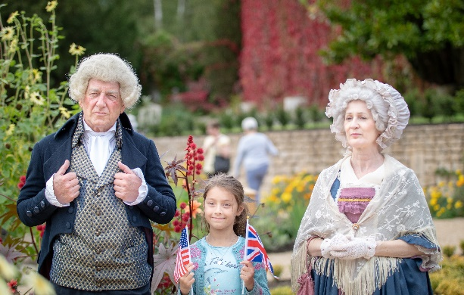
The Children’s Garden

Taking inspiration from nature, the landscape, and Native American culture, the Children’s Garden offers a magical space where children can engage with the natural world and American culture. A Woodland Circle, created with sculptural pebble seating and surrounded by lush greenery is a perfect space for picnics and parties. The Woodland Circle marks the entrance to the Children’s Garden, where children of all ages can climb wooden structures, slide and swing high into the landscape. An Eagle’s Nest high up amongst the trees is the start of a Wilderness Trail that takes visitors right across the parkland into a wilder landscape. | 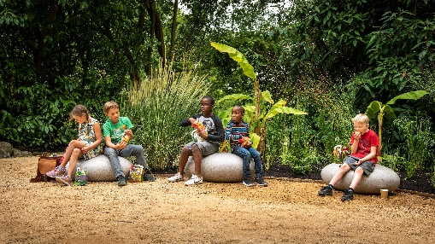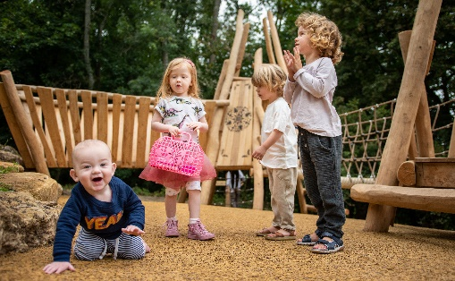

Professor Richard Wendorf  Director of the American Museum & Gardens | Corporate Partnership Contact:  Tracy Foster  Business & Development Manager  The American Museum & Gardens  Claverton Manor, Bath BA2 7BD  tracy.foster@americanmuseum.org  01225 823010 (direct line)

